Please Note: Photos (High Res.), captions, credits, a promo/trailer (embedded and downloadable), a full length, press-preview screener, locations list, and a full participants list with contact info. are all available in the pressroom of New Mexico PBS at: http://www.nmpbs.org/pressroom For interviews with the Producer/Director, please contact Chris Schueler, chris@christopherproductions.org Cell: (505) 450-9995

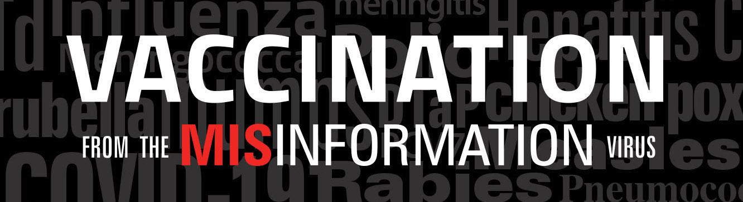

FOR IMMEDIATE RELEASE: (Date)

(Station Logo)
Presents

Vaccination From The Misinformation Virus
(Airdate/Time, Channel)

Falsehood flies and the truth comes limping after, so that when men come to be undeceived, it is too late; the jest is over and the tale has had its effect.”
Jonathan Swift, 1710

“This documentary is honest scientific information about all vaccines and
how crucial they are to community health.”
RADM (ret) Pamela Schweitzer, Pharm.D. Former Assistant Surgeon General 2021

(City, State) --- (Station ) As Covid 19 spread worldwide, Americans became increasingly polarized as to its reach, scope and effects. As a result, vaccinations for this and other diseases have become flash-points in communities across the country.

VACCINATION FROM THE MISINFORMATION VIRUS airs ( Day / Date / Time ) on (Station / Channel) _____. This one-hour documentary will help parents and community leaders understand how important and safe vaccines are, how crucial they are to community health, and how they save millions of lives annually. The program includes infectious disease experts, epidemiologists, pharmacists, physicians, and various academics with expertise in misinformation as well as health disparities.

This program is being made available nationally, along with short elements for use by health care professionals and on social media. It has been created by Emmy © Award winning producer/director Chris Schueler.

“Our lifespan for most of human history is short. We had 40 years if we were lucky and 40% to 45% of kids, depending on the era of history, died before the age of 5. So the idea that we get these long lives … we can expect to see our children grow up. This is a gift of science.”
Bette Korber, PhD Computational Biologist and Biophysicist
Los Alamos National Laboratory

“We started this program in 2017, after a conversation with infectious disease pediatrician,
Dr. Walter Dehority and in conjunction with the Immunization Practitioners Advisory Committee, so we’ve been in research over three years before we started filming,” explains producer/director Schueler. “We started long before the pandemic, and thus address all vaccines, explaining the history and science while dispelling various myths.”

According to Brian Southwell, PhD a health communications professor at Duke and UNC Chapel Hill, “We have motivations for the information that we seek. We can be blind to information that really is at odds with what we thought was the way that the world worked.”

More information and a free downloadable viewer guide can be found at www.themisinformationvirus.com

MORE ABOUT THE DOCUMENTARY:

“The medicine that has saved more lives than anything else is vaccines.
It’s really a remarkable contribution to human health.”
John D. Grabenstein, RPh, PhD

While discussions around vaccinations have become heated, former Assistant US Surgeon General, Pamela Schweitzer is encouraged, “Our hopes to slow Covid 19 and get back to some kind of ‘normal’ hinges on peoples’ understanding of and willingness to become vaccinated. And that understanding and willingness will carry over to other vaccines.” According to Dr. Walter Dohority, “The pandemic has really offered us an opportunity to educate and engage citizens about all vaccines and viruses.”
The difficulty with people understanding the importance of vaccination may have to do with how successful vaccines have been. “I don’t know anybody who’s ever had measles. I’ve never seen mumps. I’ve never seen rubella. Now my children, they don’t even know what chickenpox is,” explains the Director of Tricore Labs infectious diseases, Karissa Culbreath, PhD. “That’s the challenge of the vaccines arguments because now disease doesn’t happen and we have to remind people who’ve never seen the disease that the disease exists.”

“We have to understand that folks may be hesitant to get vaccinated for reasons we may not consider,” says Schueler. “Our experts explain how all kinds of issues throughout the country contribute to extremely legitimate concerns for many disenfranchised groups.” “If you think about the healthcare system as a system that is part of a larger structure, part of an educational system, part of a law enforcement system, part of a social services system. Then we understand why there could be hesitancy. We understand why there could be a lack of trust,” explains Sabrina Cherry, PhD. “People sometimes think of historical trauma as the retelling of bad stories that happened a long time ago, but that’s not it. It is the trauma that occurred, that continues to occur on a daily basis.”

The program also addresses the future of vaccines which appears to be bright. “The good news is that two technologies that were in development have now been proven to be really effective,” explains John Grabenstein, RPh PhD of the Immunization Action Coalition. “Now scientists can go back into the labs and test them against viruses and bacteria where there is no vaccine right now.”

The program is underwritten by: Presbyterian Healthcare Services, STChealth, LLC, The City of Albuquerque and SafeTeen New Mexico. With additional support from: New Mexico Hospital Association, American Society of Health-System Pharmacists, Melanie and Todd Watkins, Rear Admiral Pamela Schweitzer, USPHS (ret) and Mr. Paul Schweitzer, The Rotary Club of Albuquerque,
American Association of Colleges of Pharmacy, National Alliance of State Pharmacy Associations,
American Pharmacists Association Foundation, Pharmacists Public Health Initiative, National Community Pharmacists Association, Western Sky Community Care, State Farm Insurance, Blue Cross and Blue Shield of New Mexico and New Mexico Association of Counties,
Dr. Melissa Martinez and Mr. Mario Martinez, The Immunization Practices Advisory Council and New Mexico Pediatric Society.

For more information please visit: www.themisinformationvirus.com

(Insert Station Boilerplate)

New Mexico PBS (NMPBS)
Celebrating over 60 years of service, NMPBS (KNME & KNMD-TV) serving New Mexico and the Navajo Nation, broadcasts and streams a wide array of nature, history, current affairs, health, performance, children's, educational and entertainment programs. NMPBS produces NEW MEXICO IN FOCUS, COLORES! and a variety of specials. NMPBS operates 5 digital KNME broadcast channels: 5.1, 5.2, 5.3, 5.4, and 5.5. The five KNMD channels mirror KNME, and broadcast in ATSC 3.0, the NextGenTV format. NMPBS is co-licensed to the University of New Mexico (UNM) and Albuquerque Public Schools (APS). www.nmpbs.org

Local Press Contacts:

(Insert Local Contact)

Press / Station Relations contact:
Evy Todd, Publicist/Station Relations, New Mexico PBS
(505) 265-3025; etodd@newmexicopbs.org

###
Available for interviews: Chris Schueler, Producer/Director
chris@christopherproductions.org Cell: 505-450-9995

Participants are also available for interviews.

